**Indira Gandhi Delhi Technical University for Women**

**(Established by Govt. of Delhi vide Act 09 of 2012)**

**(Formerly Indira Gandhi Institute of Technology)**

**Kashmere Gate, Delhi - 110006**



**LABORATORY FILE**

**for**

**Web Technologies**

**MCA 207**

**Submitted by:**

**Submitted to:**

Ms. Ankita Singh Roopal Mittal

MCA, 3rd Sem

02004092019

**Date: 15-09-2020**

**LAB 6 WORK**

**Ques 1: Create a simple business card (name, phone (type: work and home), email id, company name) in XML. Add CSS styling to business_card.xml.**

**XML Code:**

<?xml version="1.0" encoding="UTF-8"?>

<?xml-stylesheet type="text/css" href="business_card.css"?>

<businesscard>

<name>Roopal Mittal</name>

<phone type="Home">8588910234</phone>

<phone type="Work">9201372843</phone>

<email>roopal.mca@gmail.com</email>

<company>Qboard_secure</company>

</businesscard>

**CSS Code:**

businesscard

{

font-family: Verdana;

font-size: 18px;

color: black;

display: block;

padding: 10px;

margin: 20px;

background-color:#d2f7de;

width: 400px;

border: 5px;

border: 2px solid;

text-align: left;

}

name

{

display: block;

font-weight: bold;

}

phone

{

display: block;

}

company

{

display:block;

}

email

{

display: block;

color: Red;

}

email:before { content: "Email: " }

phone:before { content:attr(type) ": " }

phone[primary]:after { content:"("attr(primary)")"}

**Output:**

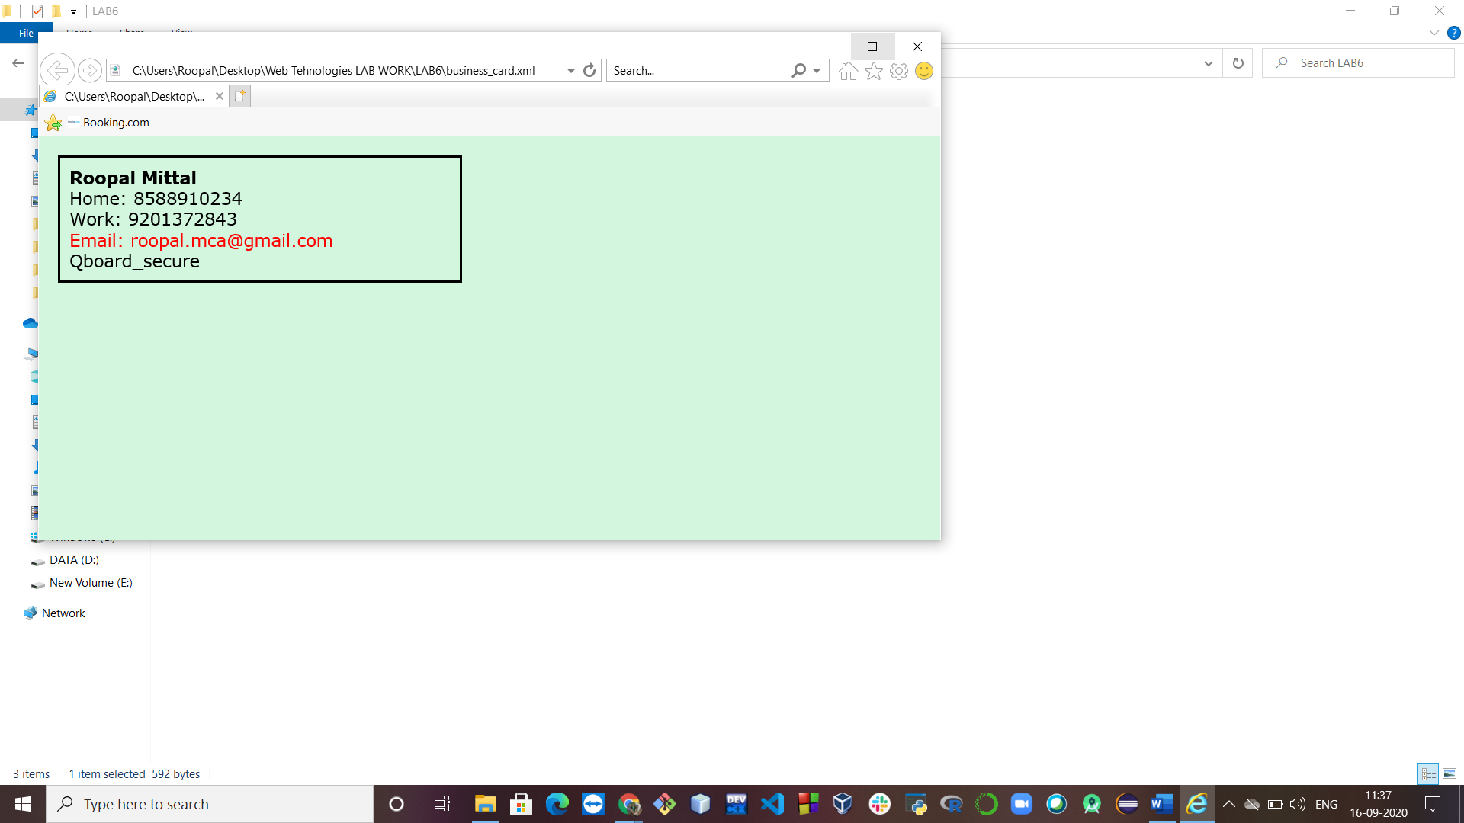

**Ques 2: Create XML for:**

**ProductListing**

**Product**

**name**

**description**

**price**

**Add CSS styling to product.css**

**XML Code:**

<?xml version="1.0" encoding="UTF-8"?>

<?xml-stylesheet type="text/css" href="product.css"?>

<productlisting>

<product>

<name>T-shirt (Men)</name>

<desc>A solid black colour PUMA t-shirt available in sizes(S, M, L, XL)</desc>

<price>Rs. 2000</price>

</product>

<product>

<name>Track pant (Unisex)</name>

<desc>A blue colour ADIDAS track pant with neon green strips available in sizes(S, M, L, XL)</desc>

<price>Rs. 2500</price>

</product>

<product>

<name>Yoga pant(Women)</name>

<desc>A strechable gray colour skin fit yoga pant available in sizes(S, M, L, XL) </desc>

<price>Rs. 700</price>

</product>

</productlisting>

**CSS Code:**

product

{

font-family: monospace;

font-size: 14px;

color: DarkBlue;

display: block;

padding: 20px;

margin: 20px;

border: 2px solid;

border-color: black;

background-color: #fcf2fc;

width: 500px;

}

name

{

display: block;

font-weight:bold;

}

desc

{

display: block;

color:#2d025e;

font-style: italic;

}

price

{

color: Green;

}

**Output:**

